-- Create Database

create DATABASE NSTU_16th_batch;

USE NSTU_16th_batch;

-- Create Table

create table STUDENT_INFO(

name varchar(50),

roll int(30),

session varchar(30),

course varchar(30),

marks varchar(20)

);

-- Insert Value

INSERT INTO STUDENT_INFO(name,roll,session,course,marks) VALUES('Shifa',39,'2020-21','DC',76);

INSERT INTO STUDENT_INFO(name,roll,session,course,marks) VALUES('Jemi',40,'2020-21','ITF',80);

INSERT INTO STUDENT_INFO(name,roll,session,course,marks) VALUES('Jarir',01,'2020-21','DC',90);

INSERT INTO STUDENT_INFO(name,roll,session,course,marks) VALUES('Jarir',02,'2020-21','IPE',86);

INSERT INTO STUDENT_INFO(name,roll,session,course,marks) VALUES('Jarir',03,'2020-21','DBMS',85);

select * from STUDENT_INFO;

select Max(marks) from STUDENT_INFO;

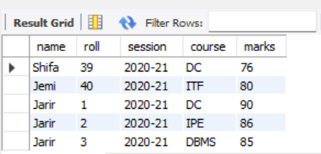 select * from STUDENT_INFO;

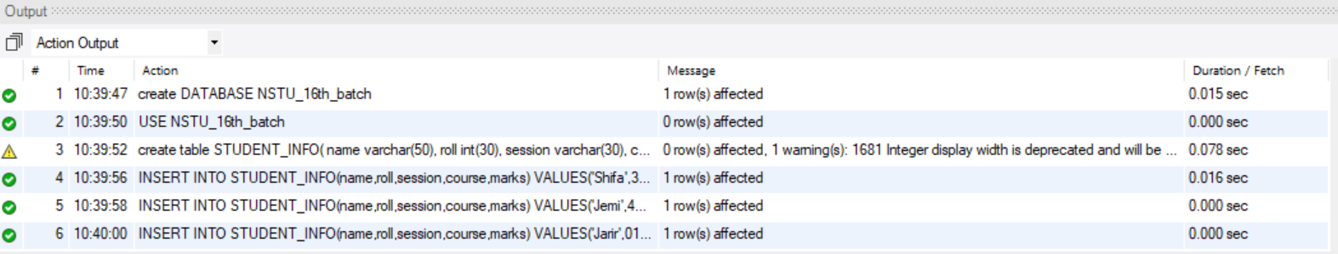

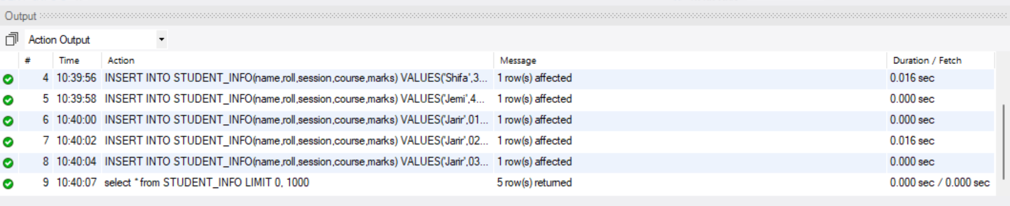

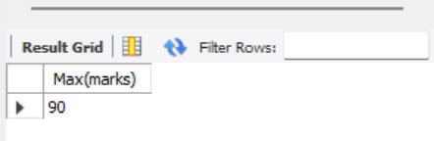 select Max(marks) from STUDENT_INFO;

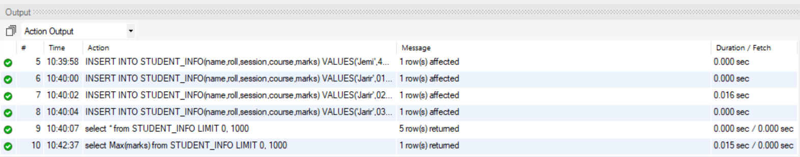

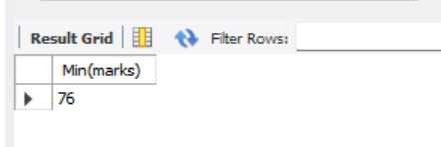 select Min(marks) from STUDENT_INFO;

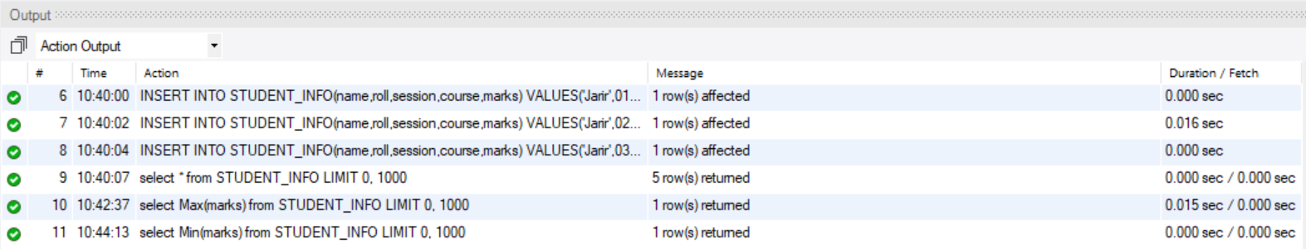

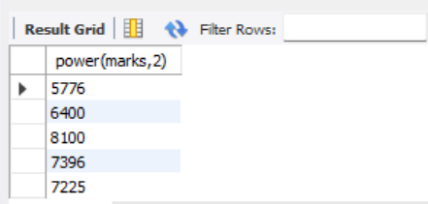 select power(marks,2)from STUDENT_INFO;

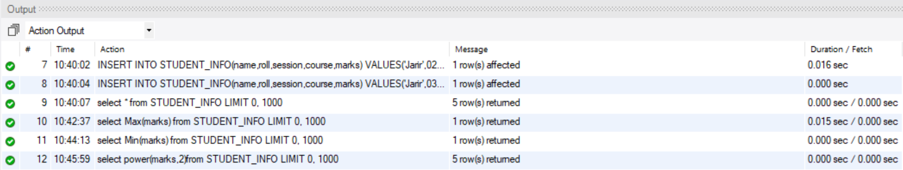

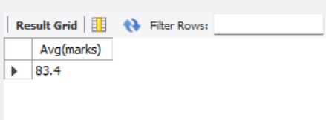 select Avg(marks) from STUDENT_INFO;

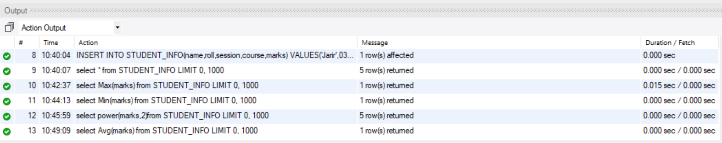

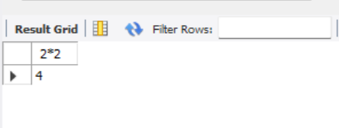 select 2*2 from dual;

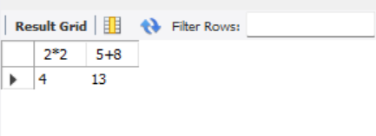 select 2*2,5+8 from dual;

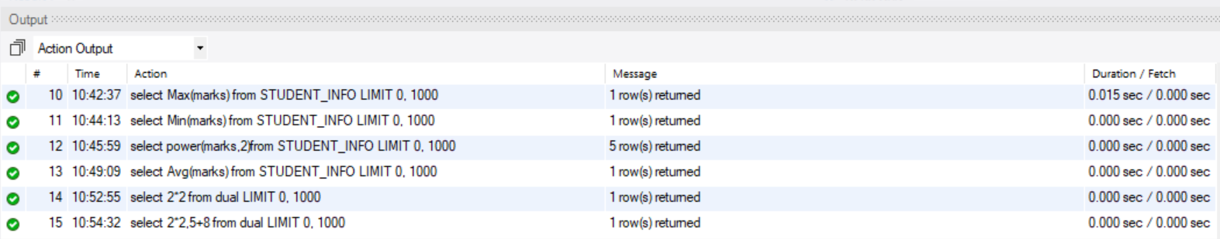

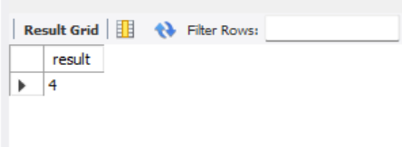 select 2*2 as result from dual;

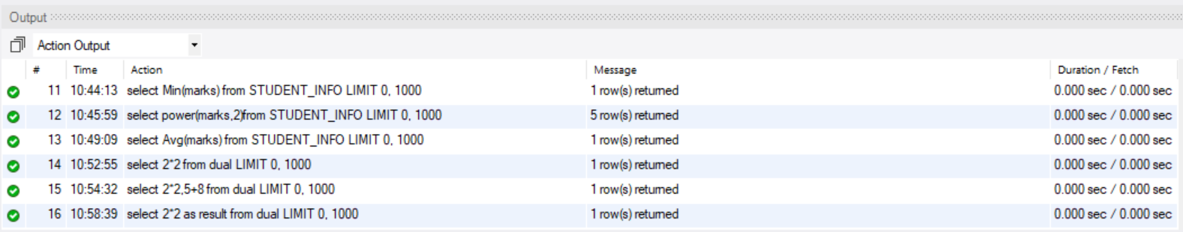

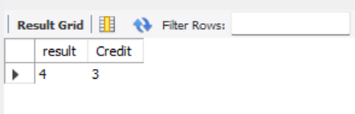 select 2*2 as result,2+1 Credit from dual;

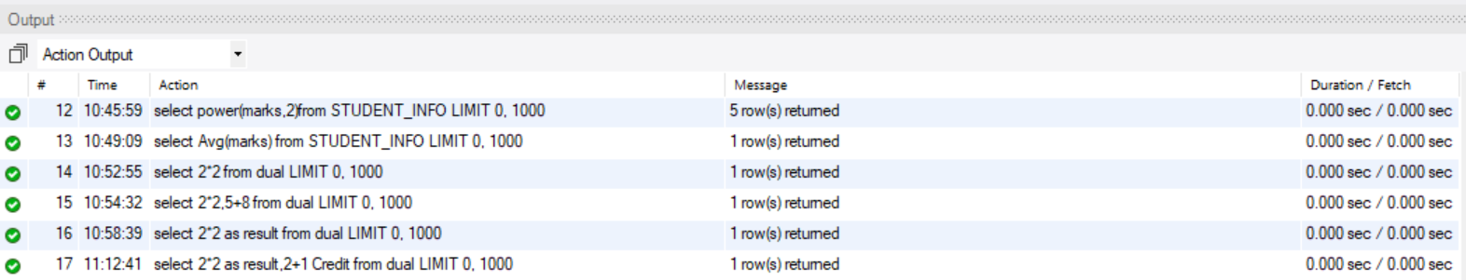

-- Create Database

create DATABASE NSTU_16th_batch;

USE NSTU_16th_batch;

-- Create Table

create table STUDENT_INFO(

name varchar(50),

roll int(30),

session varchar(30),

course varchar(30),

marks varchar(20)

);

-- Insert Value

INSERT INTO STUDENT_INFO(name,roll,session,course,marks) VALUES('Shifa',39,'2020-21','DC',76);

INSERT INTO STUDENT_INFO(name,roll,session,course,marks) VALUES('Jemi',40,'2020-21','ITF',80);

INSERT INTO STUDENT_INFO(name,roll,session,course,marks) VALUES('Jarir',01,'2020-21','DC',90);

INSERT INTO STUDENT_INFO(name,roll,session,course,marks) VALUES('Jarir',02,'2020-21','IPE',86);

INSERT INTO STUDENT_INFO(name,roll,session,course,marks) VALUES('Jarir',03,'2020-21','DBMS',85);

select * from STUDENT_INFO;

-- MAX,MIN

select Max(marks) from STUDENT_INFO;

select Min(marks) from STUDENT_INFO;

select Avg(marks) from STUDENT_INFO;

-- POWER

select power(marks,2)from STUDENT_INFO;

-- dual

select 2*2 from dual;

select 2*2,5+8 from dual;

-- alaising

select 2*2 as result from dual;

select 2*2 as result,2+1 Credit from dual;

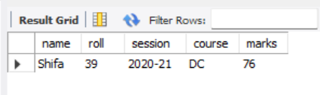select * from STUDENT_INFO where name like '%a';

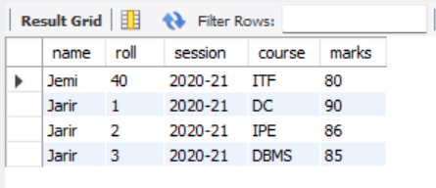select * from STUDENT_INFO where name like 'j%';

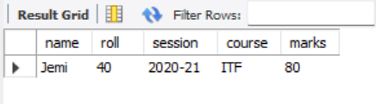 select * from STUDENT_INFO where name like '%e%';



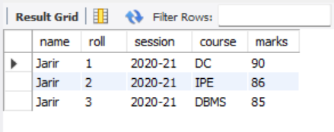 select * from STUDENT_INFO where name like '_a%';

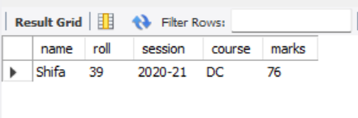 select * from STUDENT_INFO where name like '__i%';

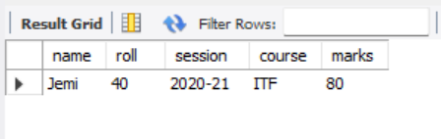select * from STUDENT_INFO where name like '_e%';

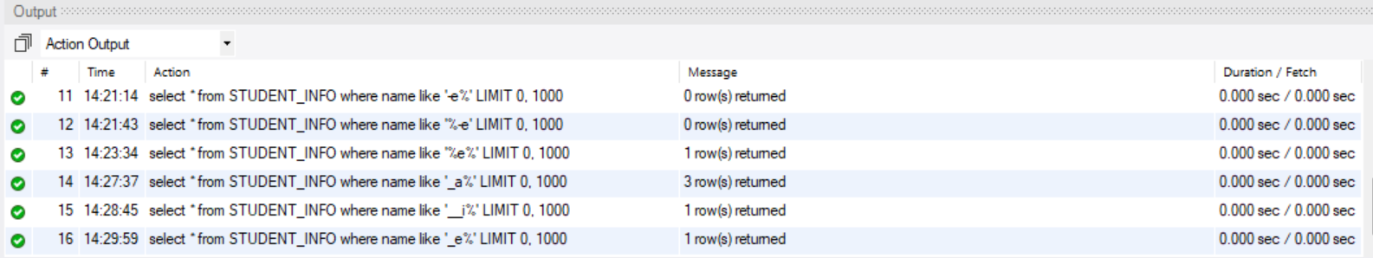

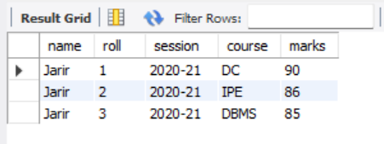 select * from STUDENT_INFO where name in('jarir');

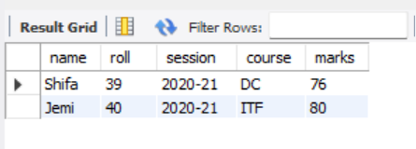 select * from STUDENT_INFO where roll in(39,40);

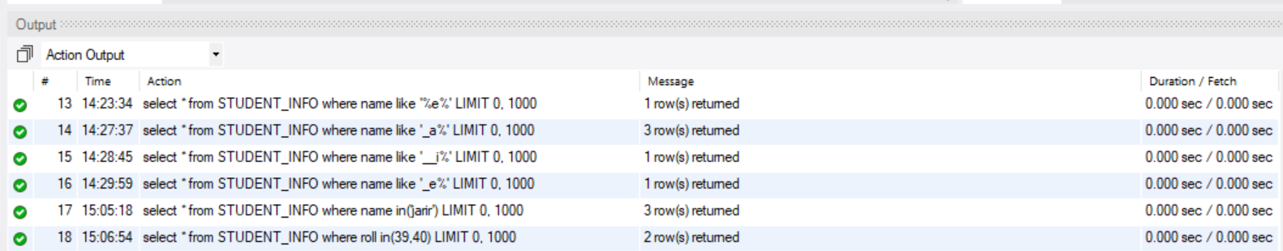

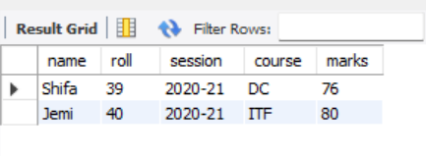 select * from STUDENT_INFO where name not in('jarir');

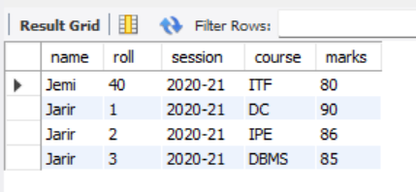 select * from STUDENT_INFO where roll not in(39);

